1. Create a bar chart

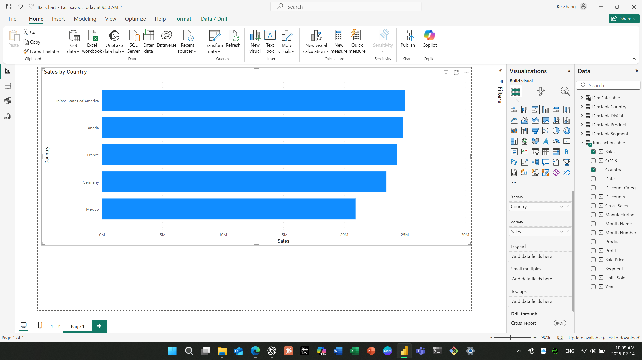

1. Apply filters to visuals

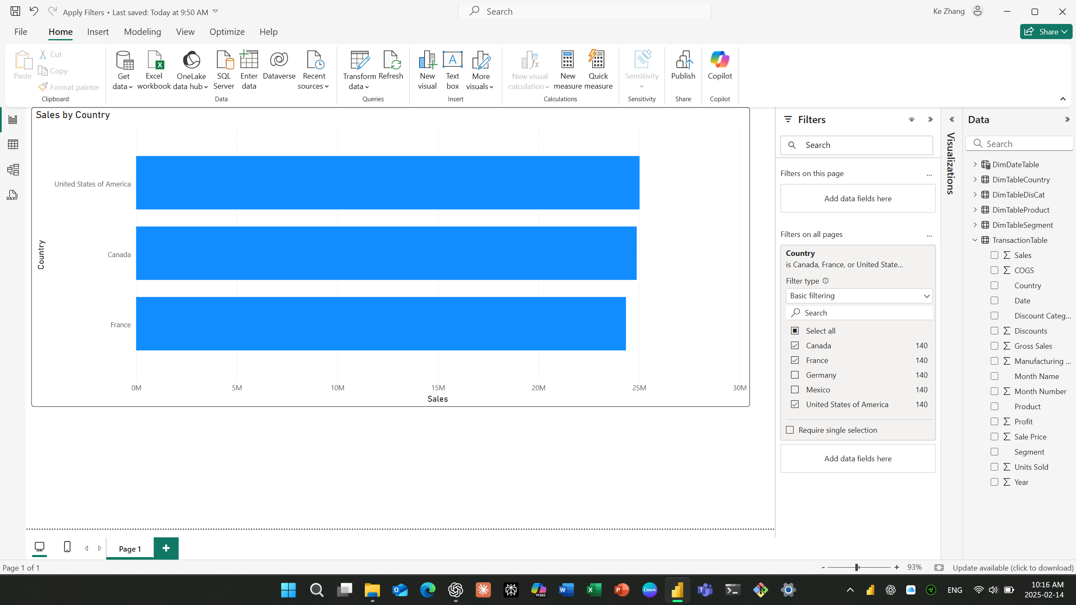

1. Apply Filters to more than one Visual at a time

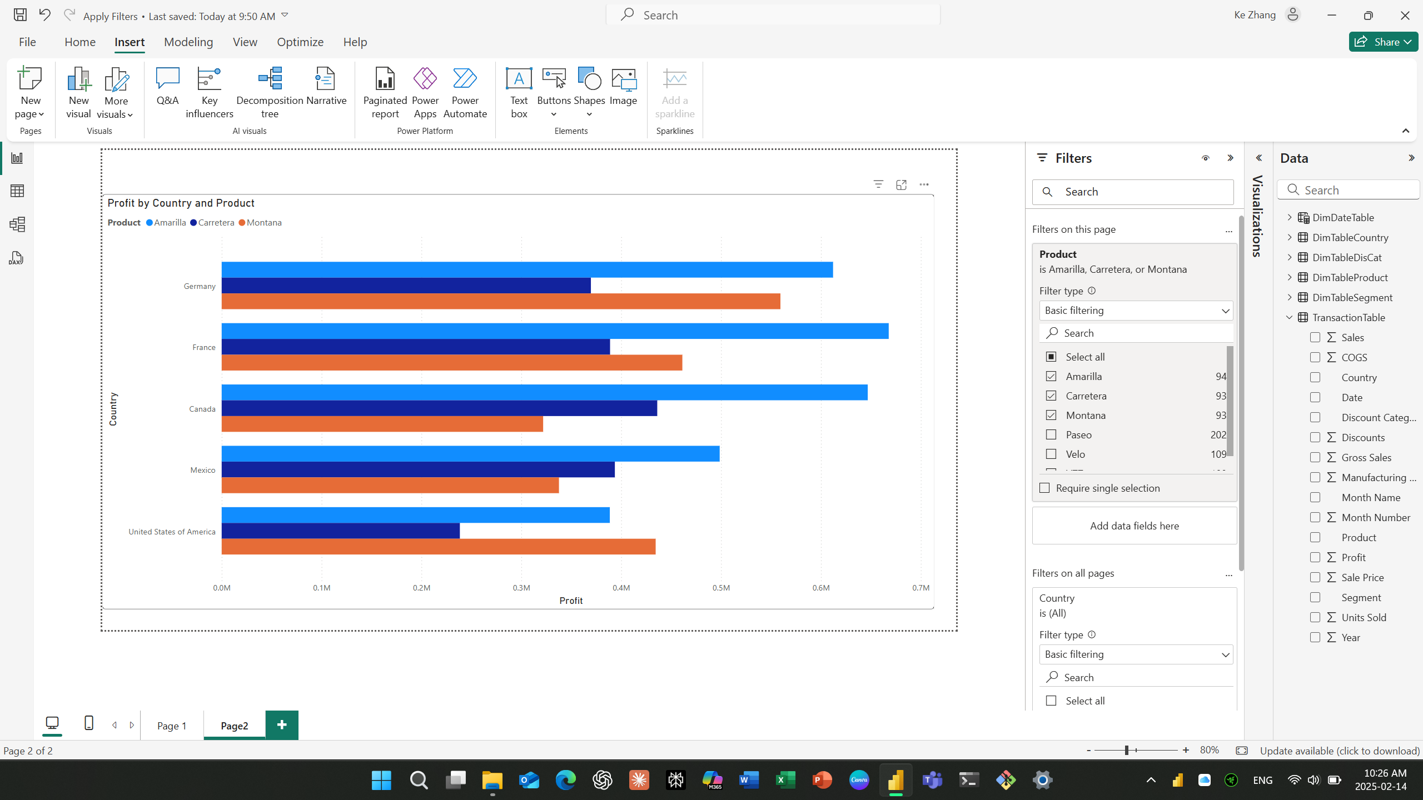

1. Remove filter

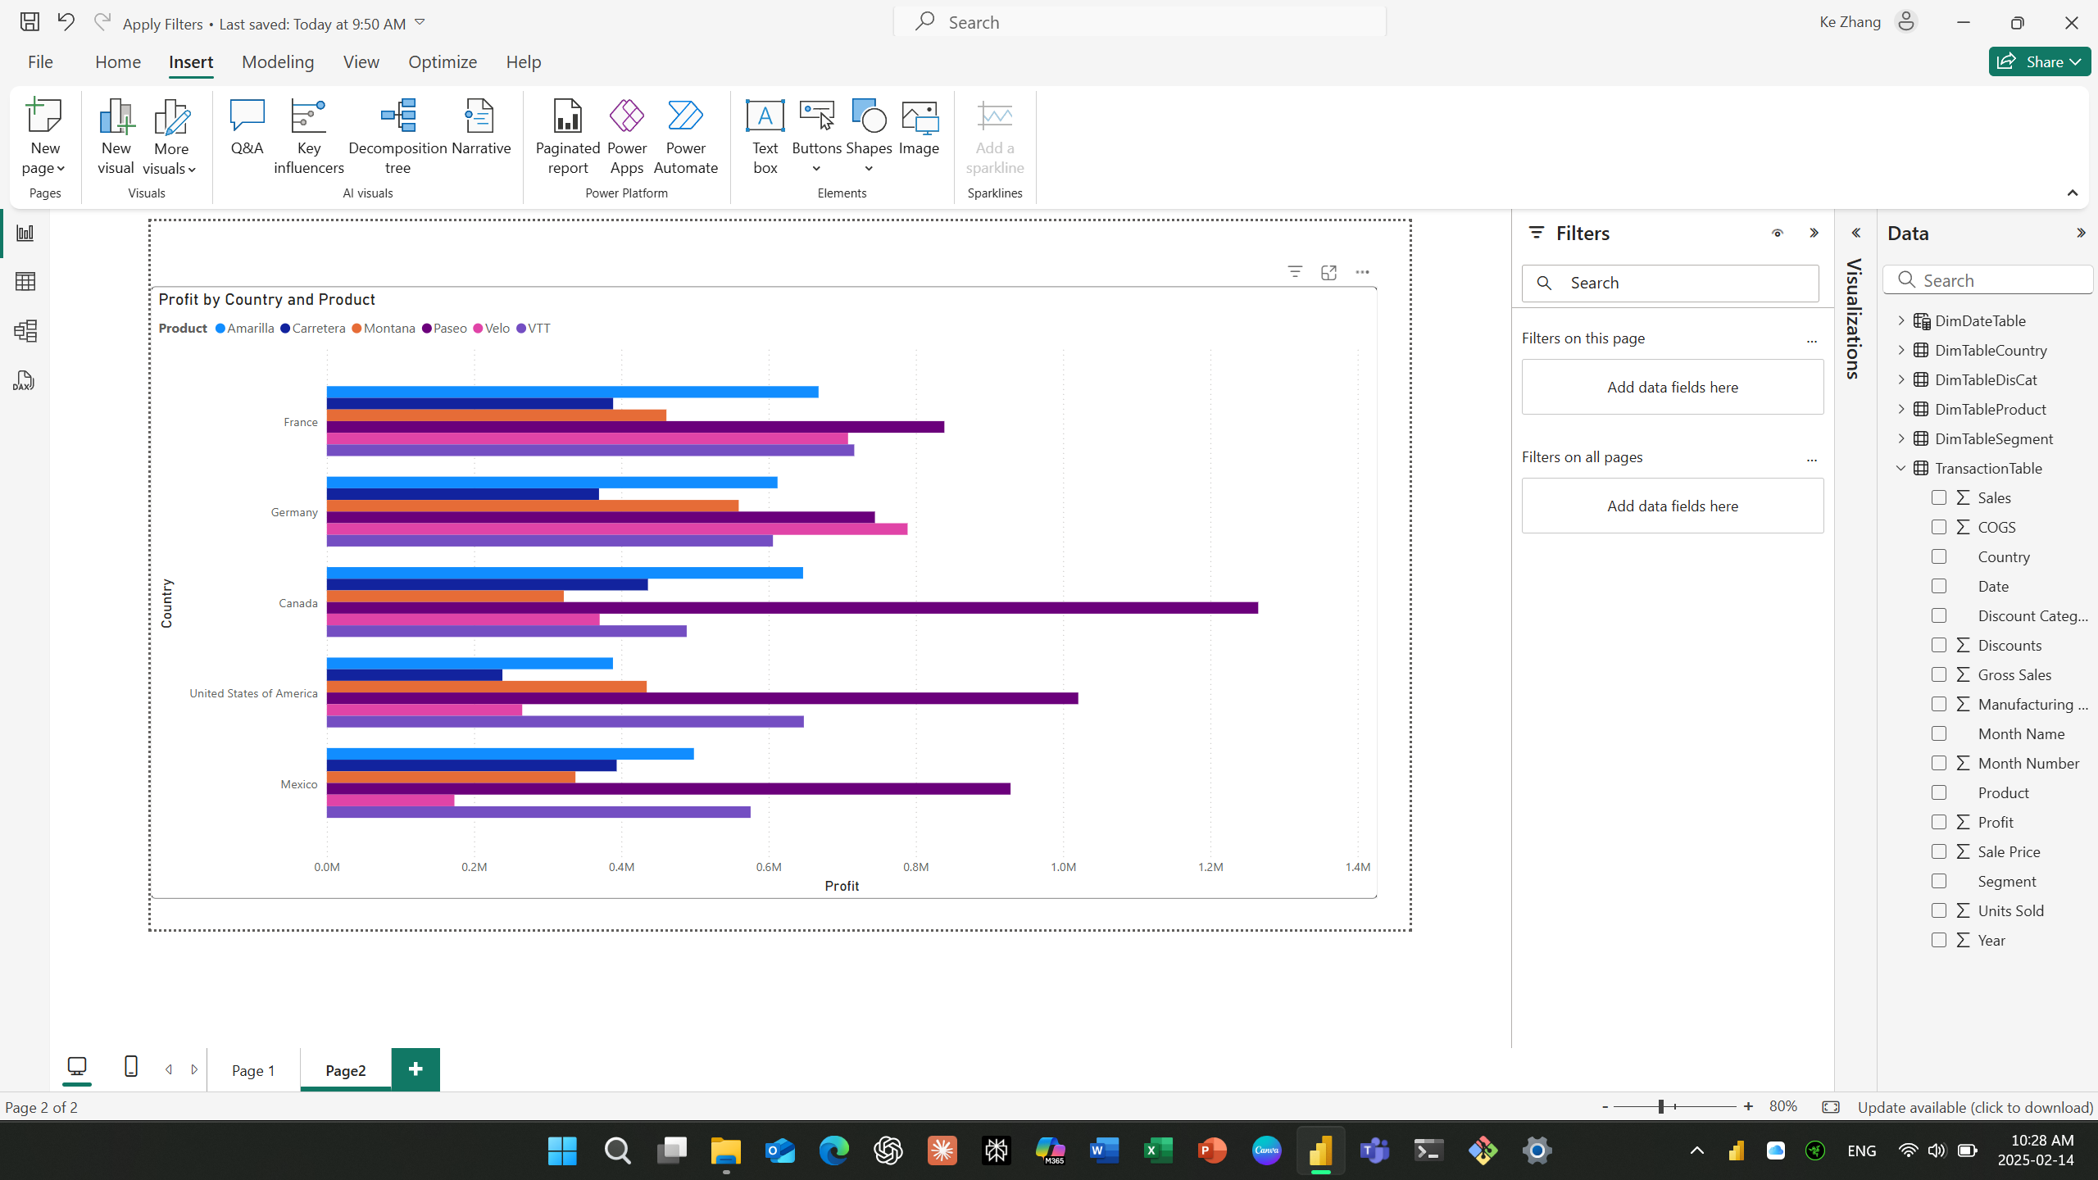

1. Format the Y-axis of a bar chart

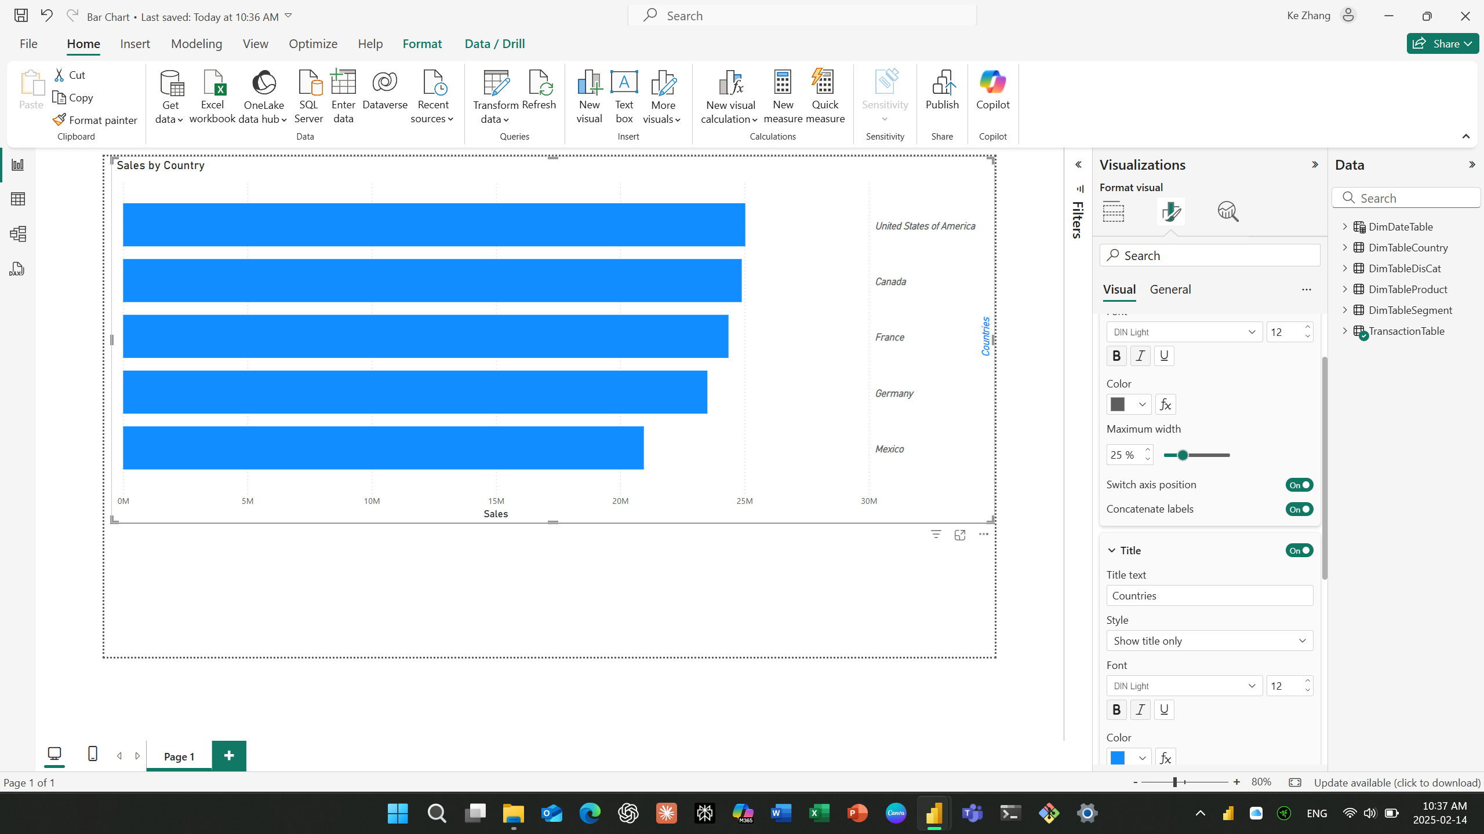

1. Format the X-axis of a bar chart.

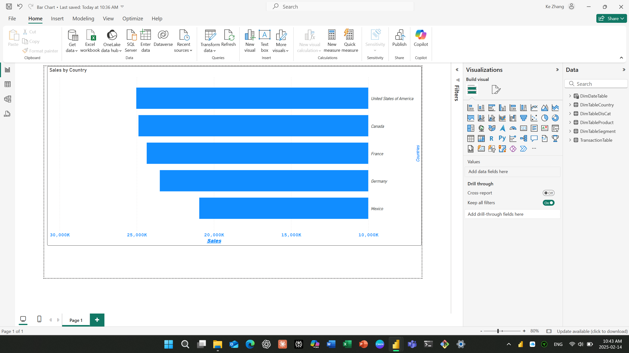

1. Add and Format the Data Category of a Clustered Bar Chart

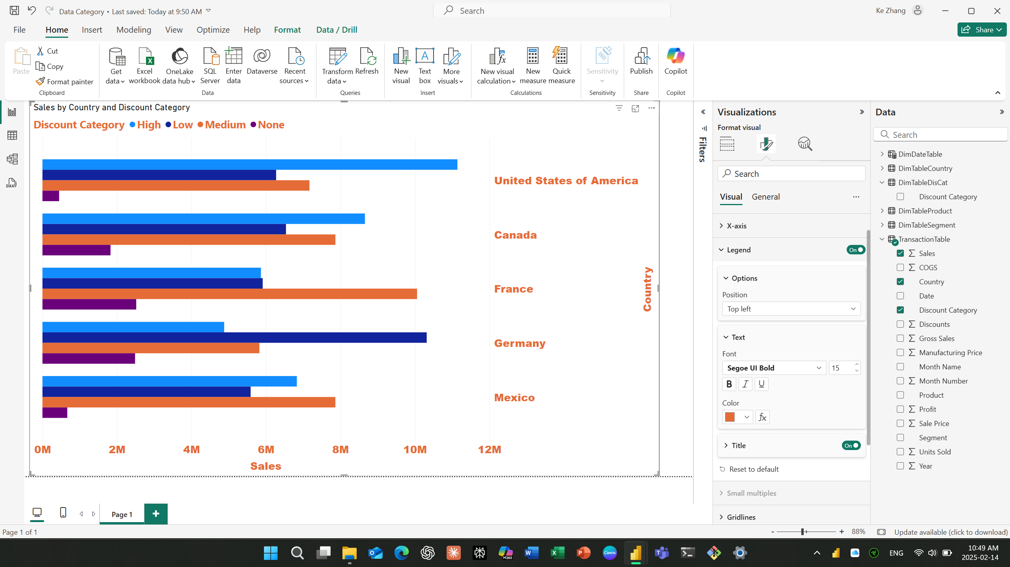

1. Move a Bar Chart’s Legend and Add Gridlines

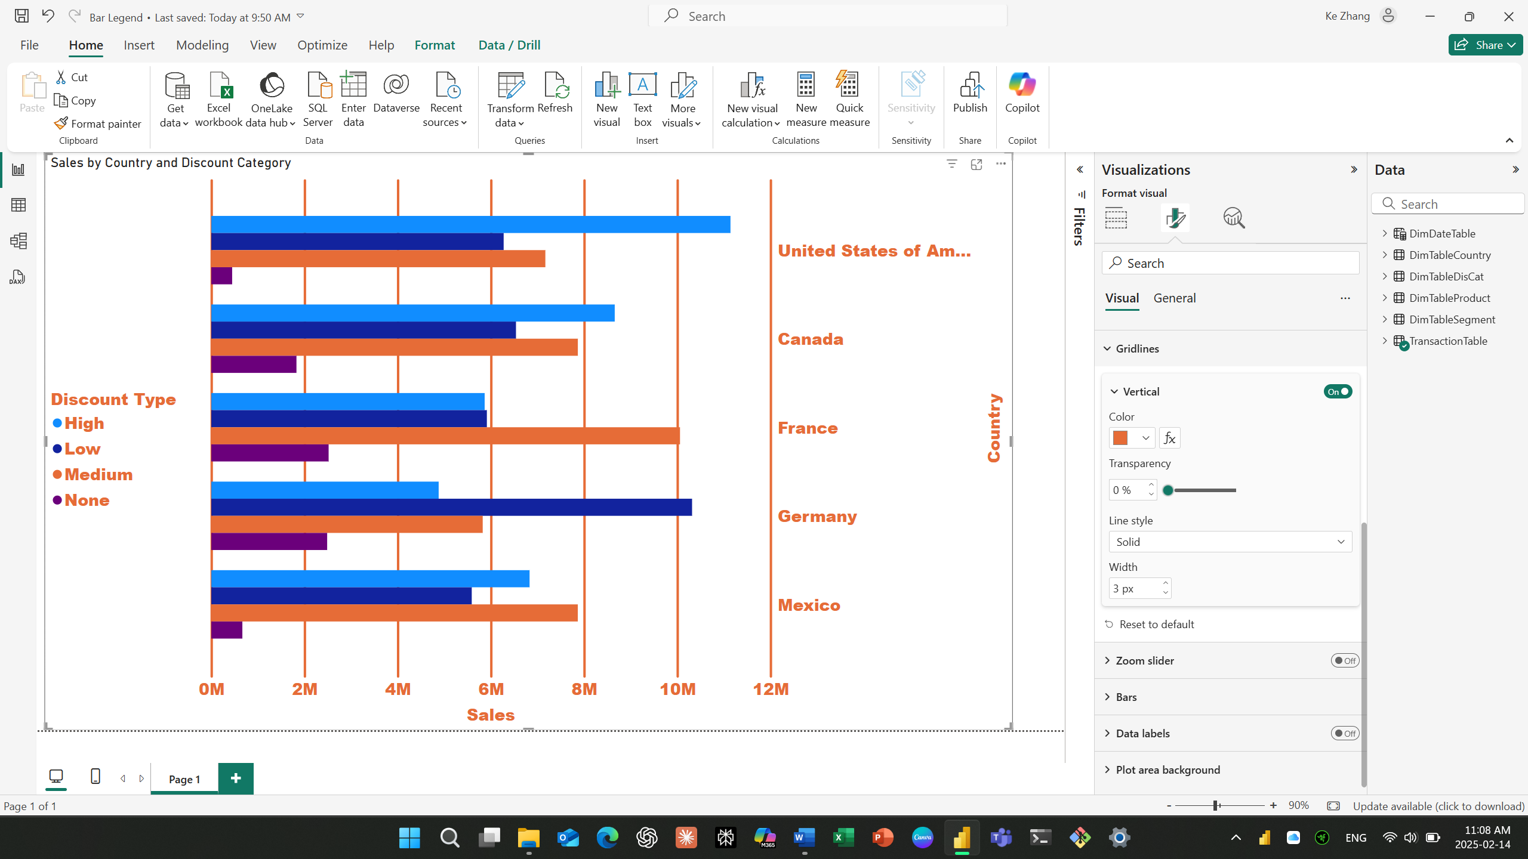

Question: What controls the spacing between the gridlines?

Answer: The minimum and maximum value of Axis range, Power BI will automatically set a space of the gridlines, but we can format the interval at x Axis or Y Axis Format-> Axis.

1. Add a Zoom slider and Update Bar Colors

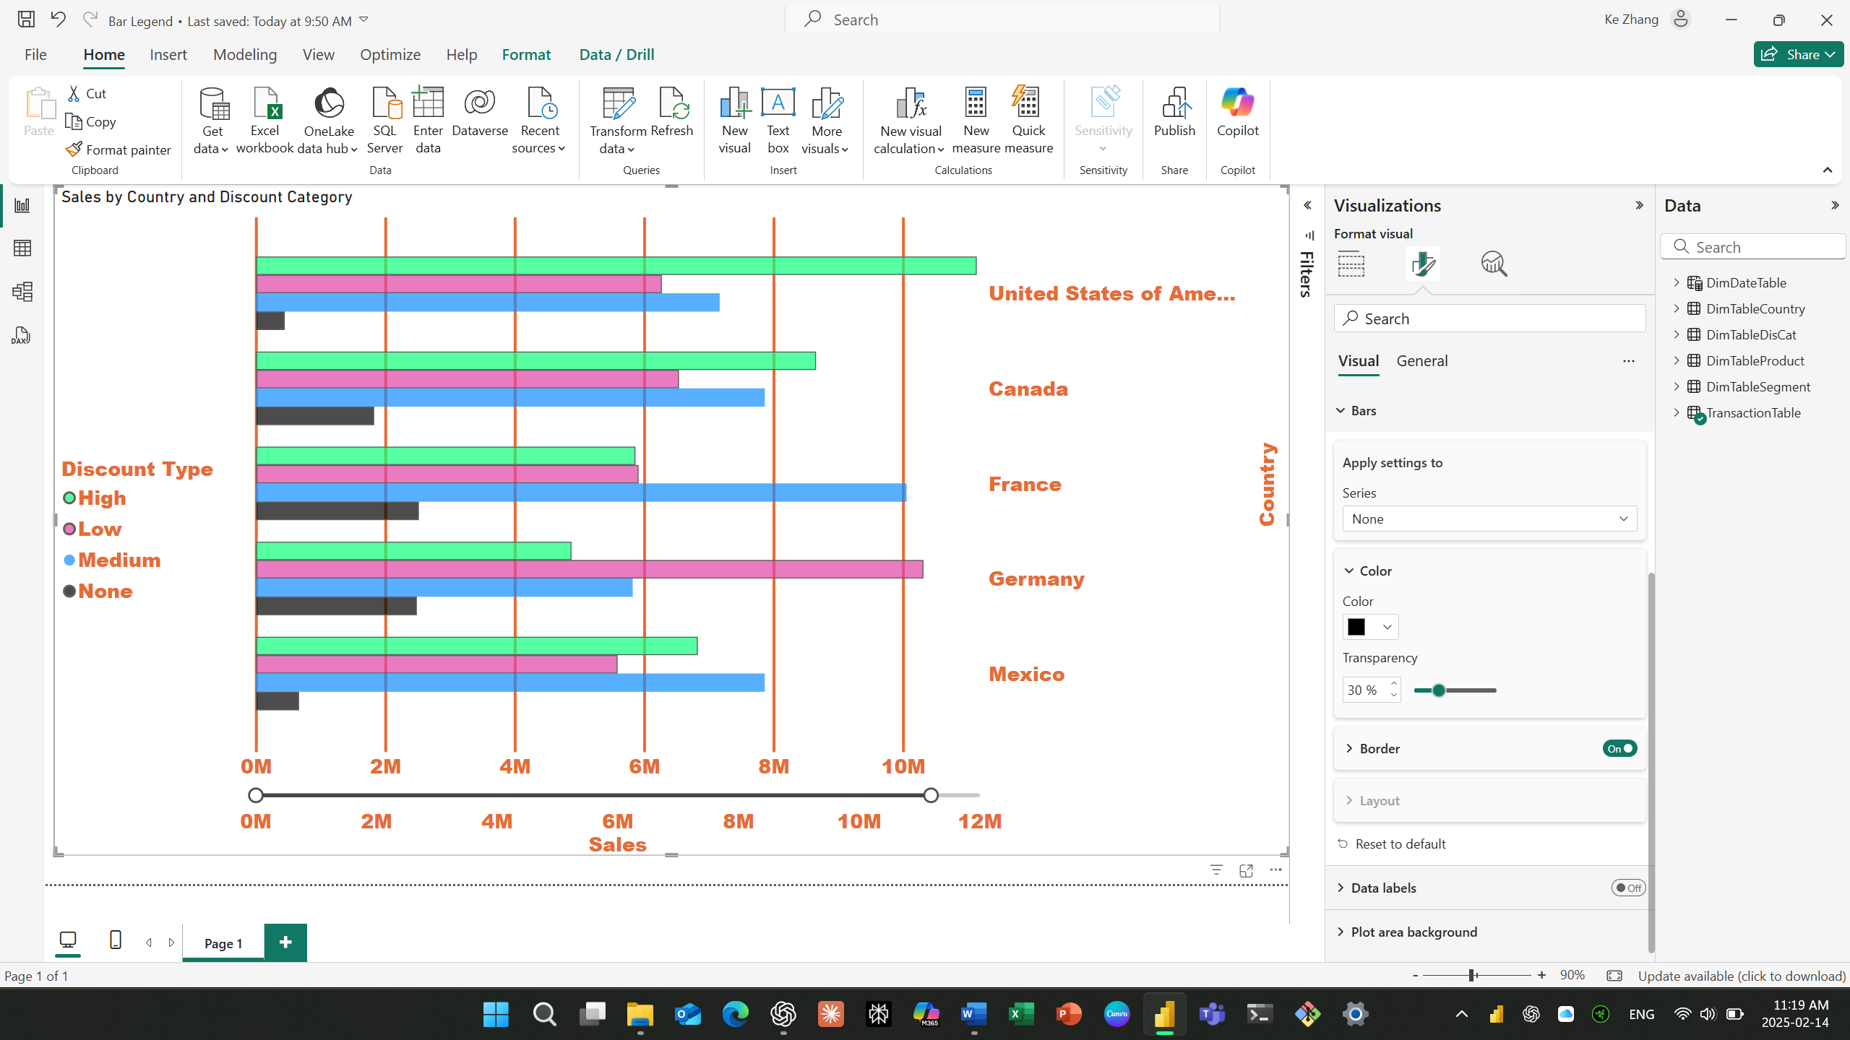

1. Add Data labels to Bar Chart

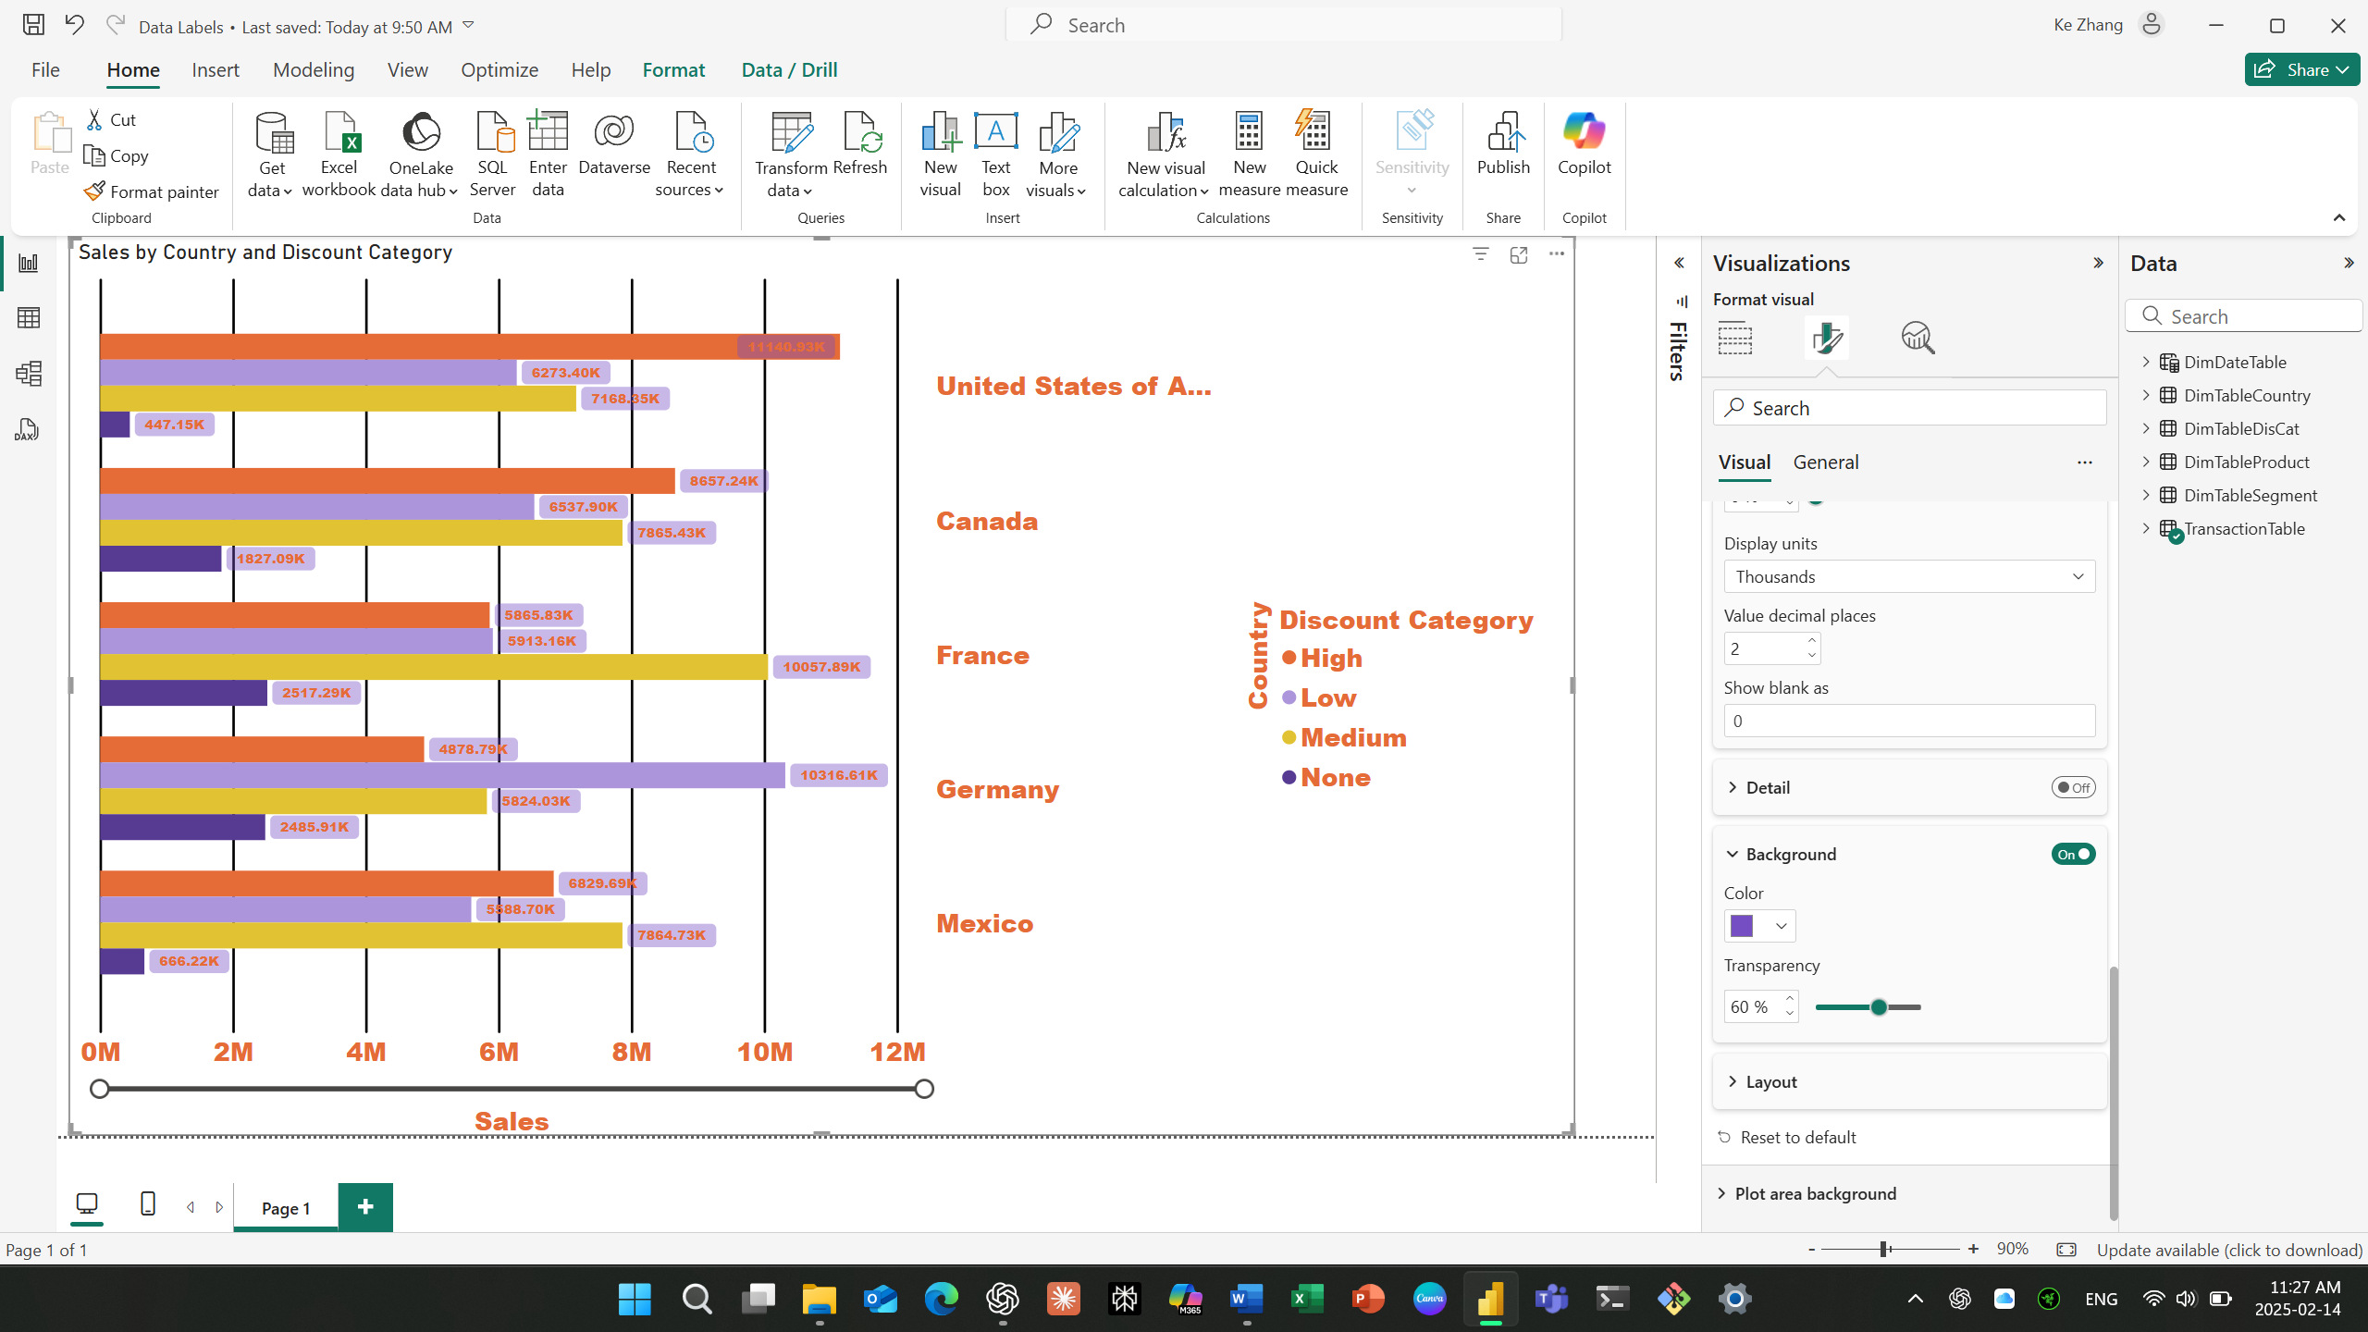

1. Add an Image to the Plot Area Background

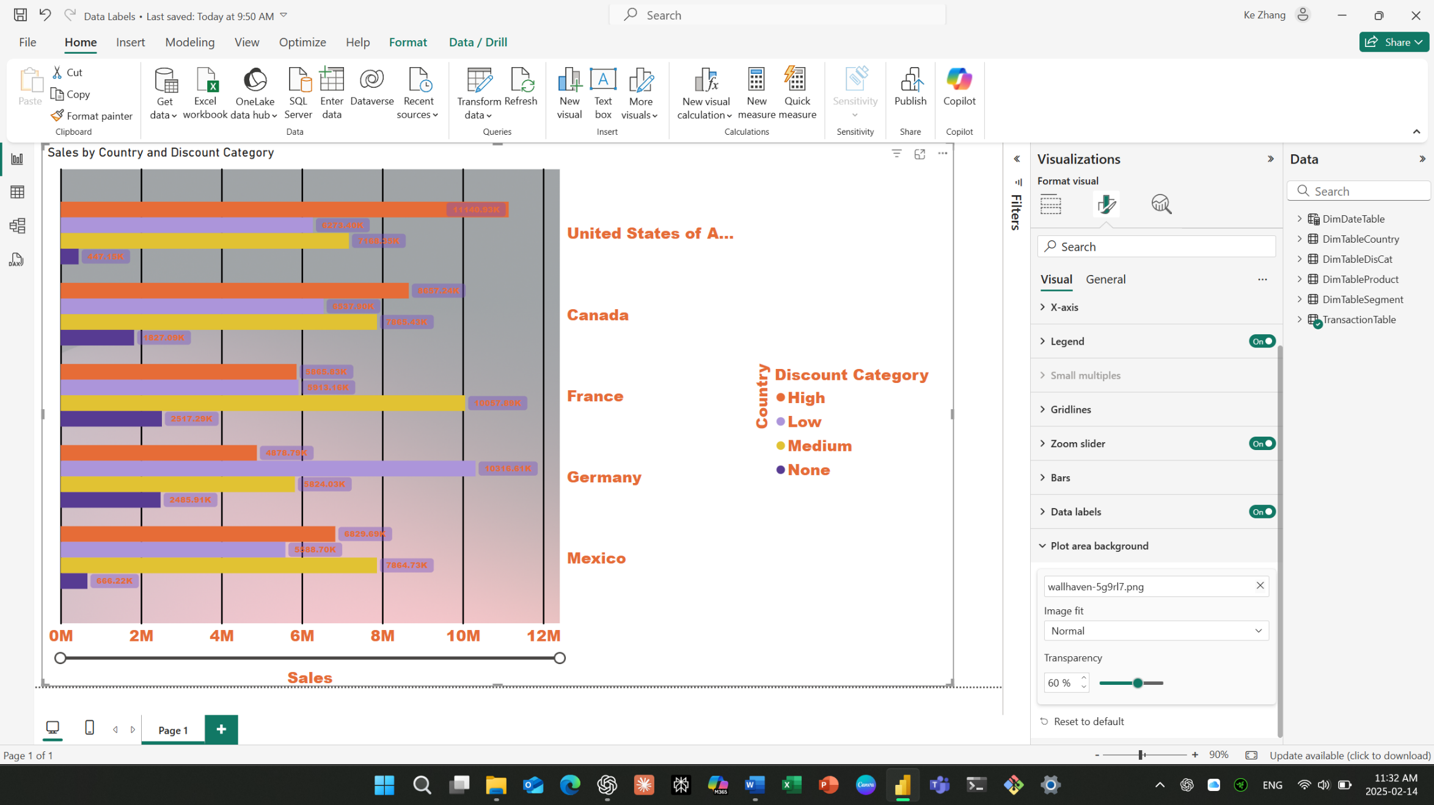

1. Create a line Chart or Area Chart

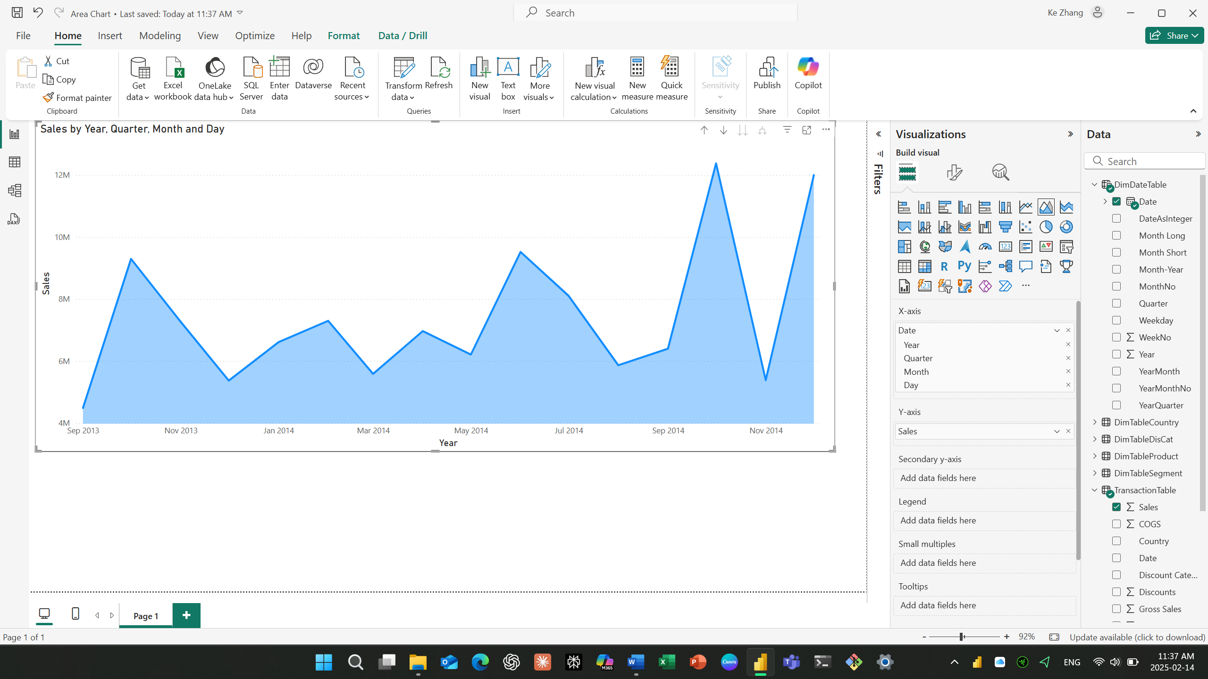

1. Creating a Drill Down through the Hierarchy

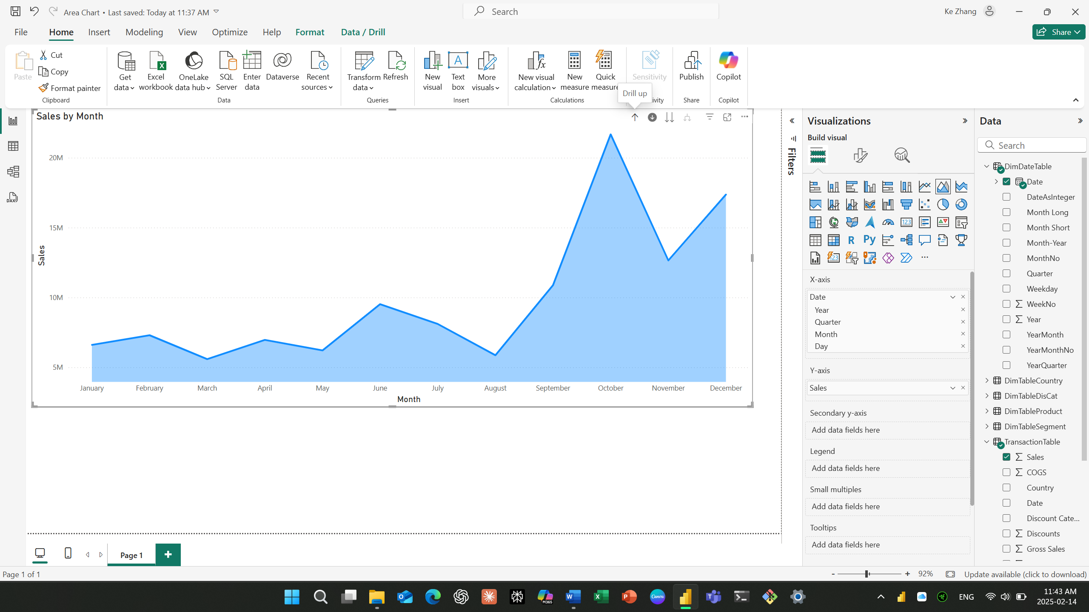

1. Format the Axes of a Line or Area Chart

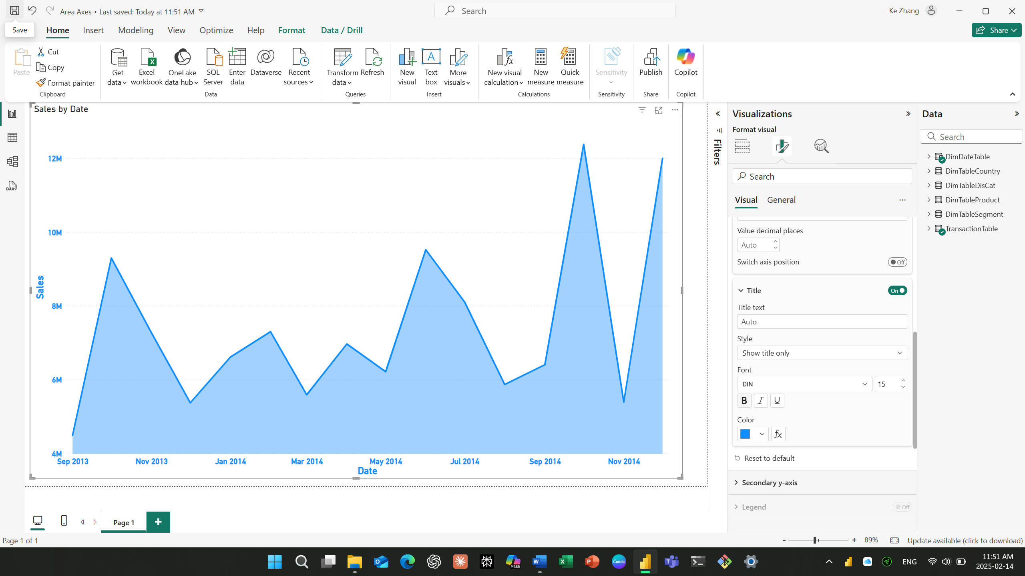

1. Adding a Legend to a line or Area Chart and Format the Legend

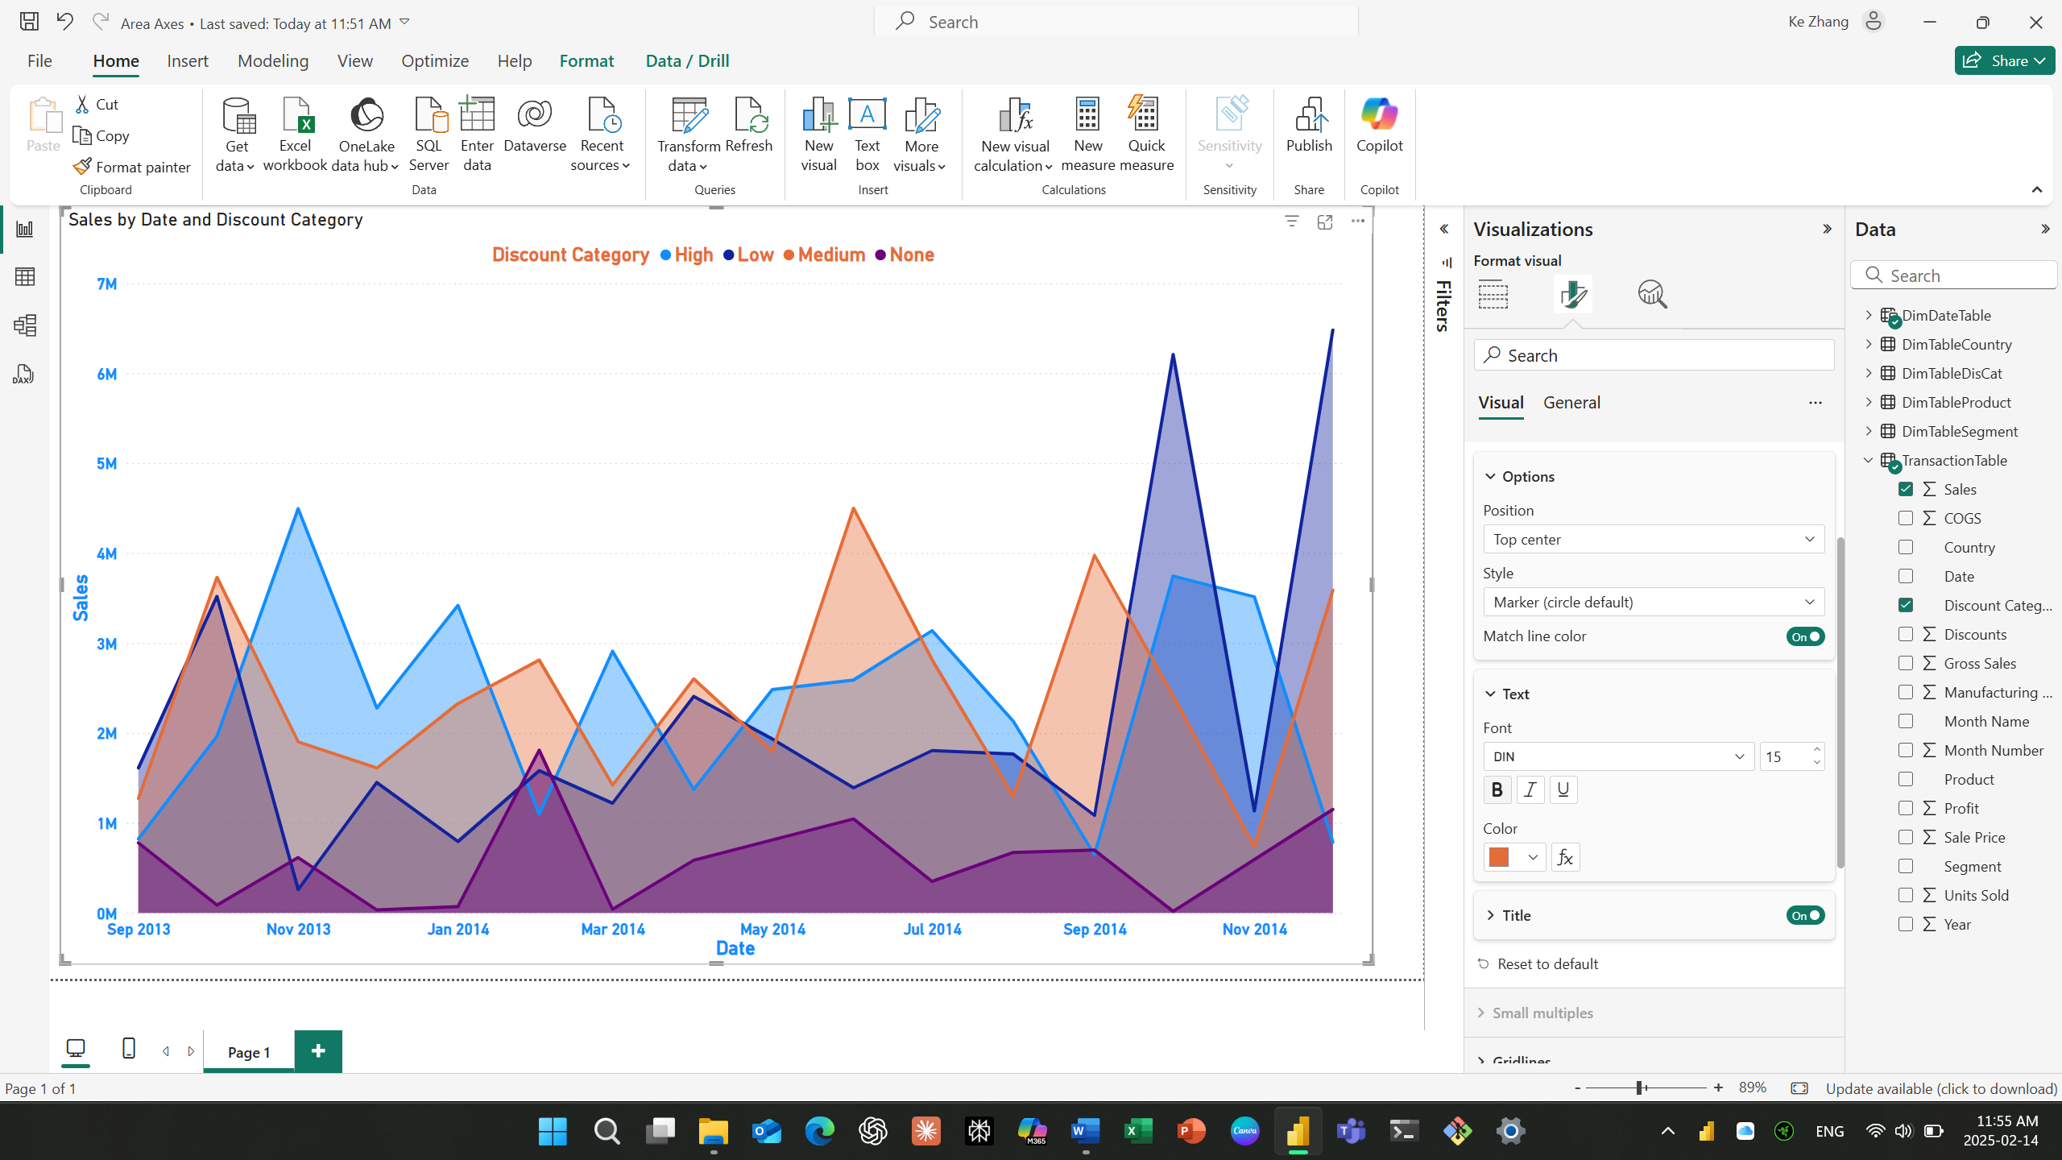

Question: How does the Legend in a Line or Area chart differ from the legend in a bar chart?

Answer: In a bar chart, the legend represents different categories by using the different bars. But in a line chart and an area chart, the legend represents different series of data by using different lines and areas.

Question What does the fx Button to the right of the Color selector do:

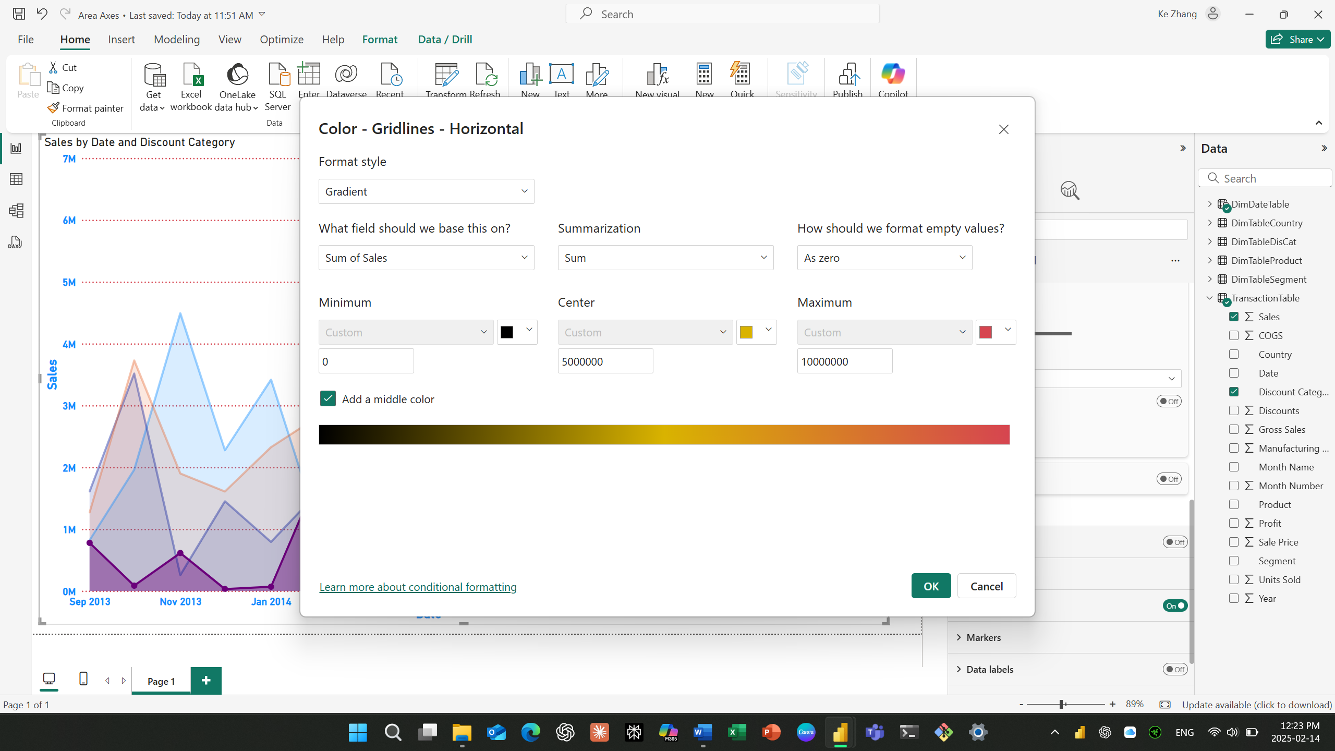

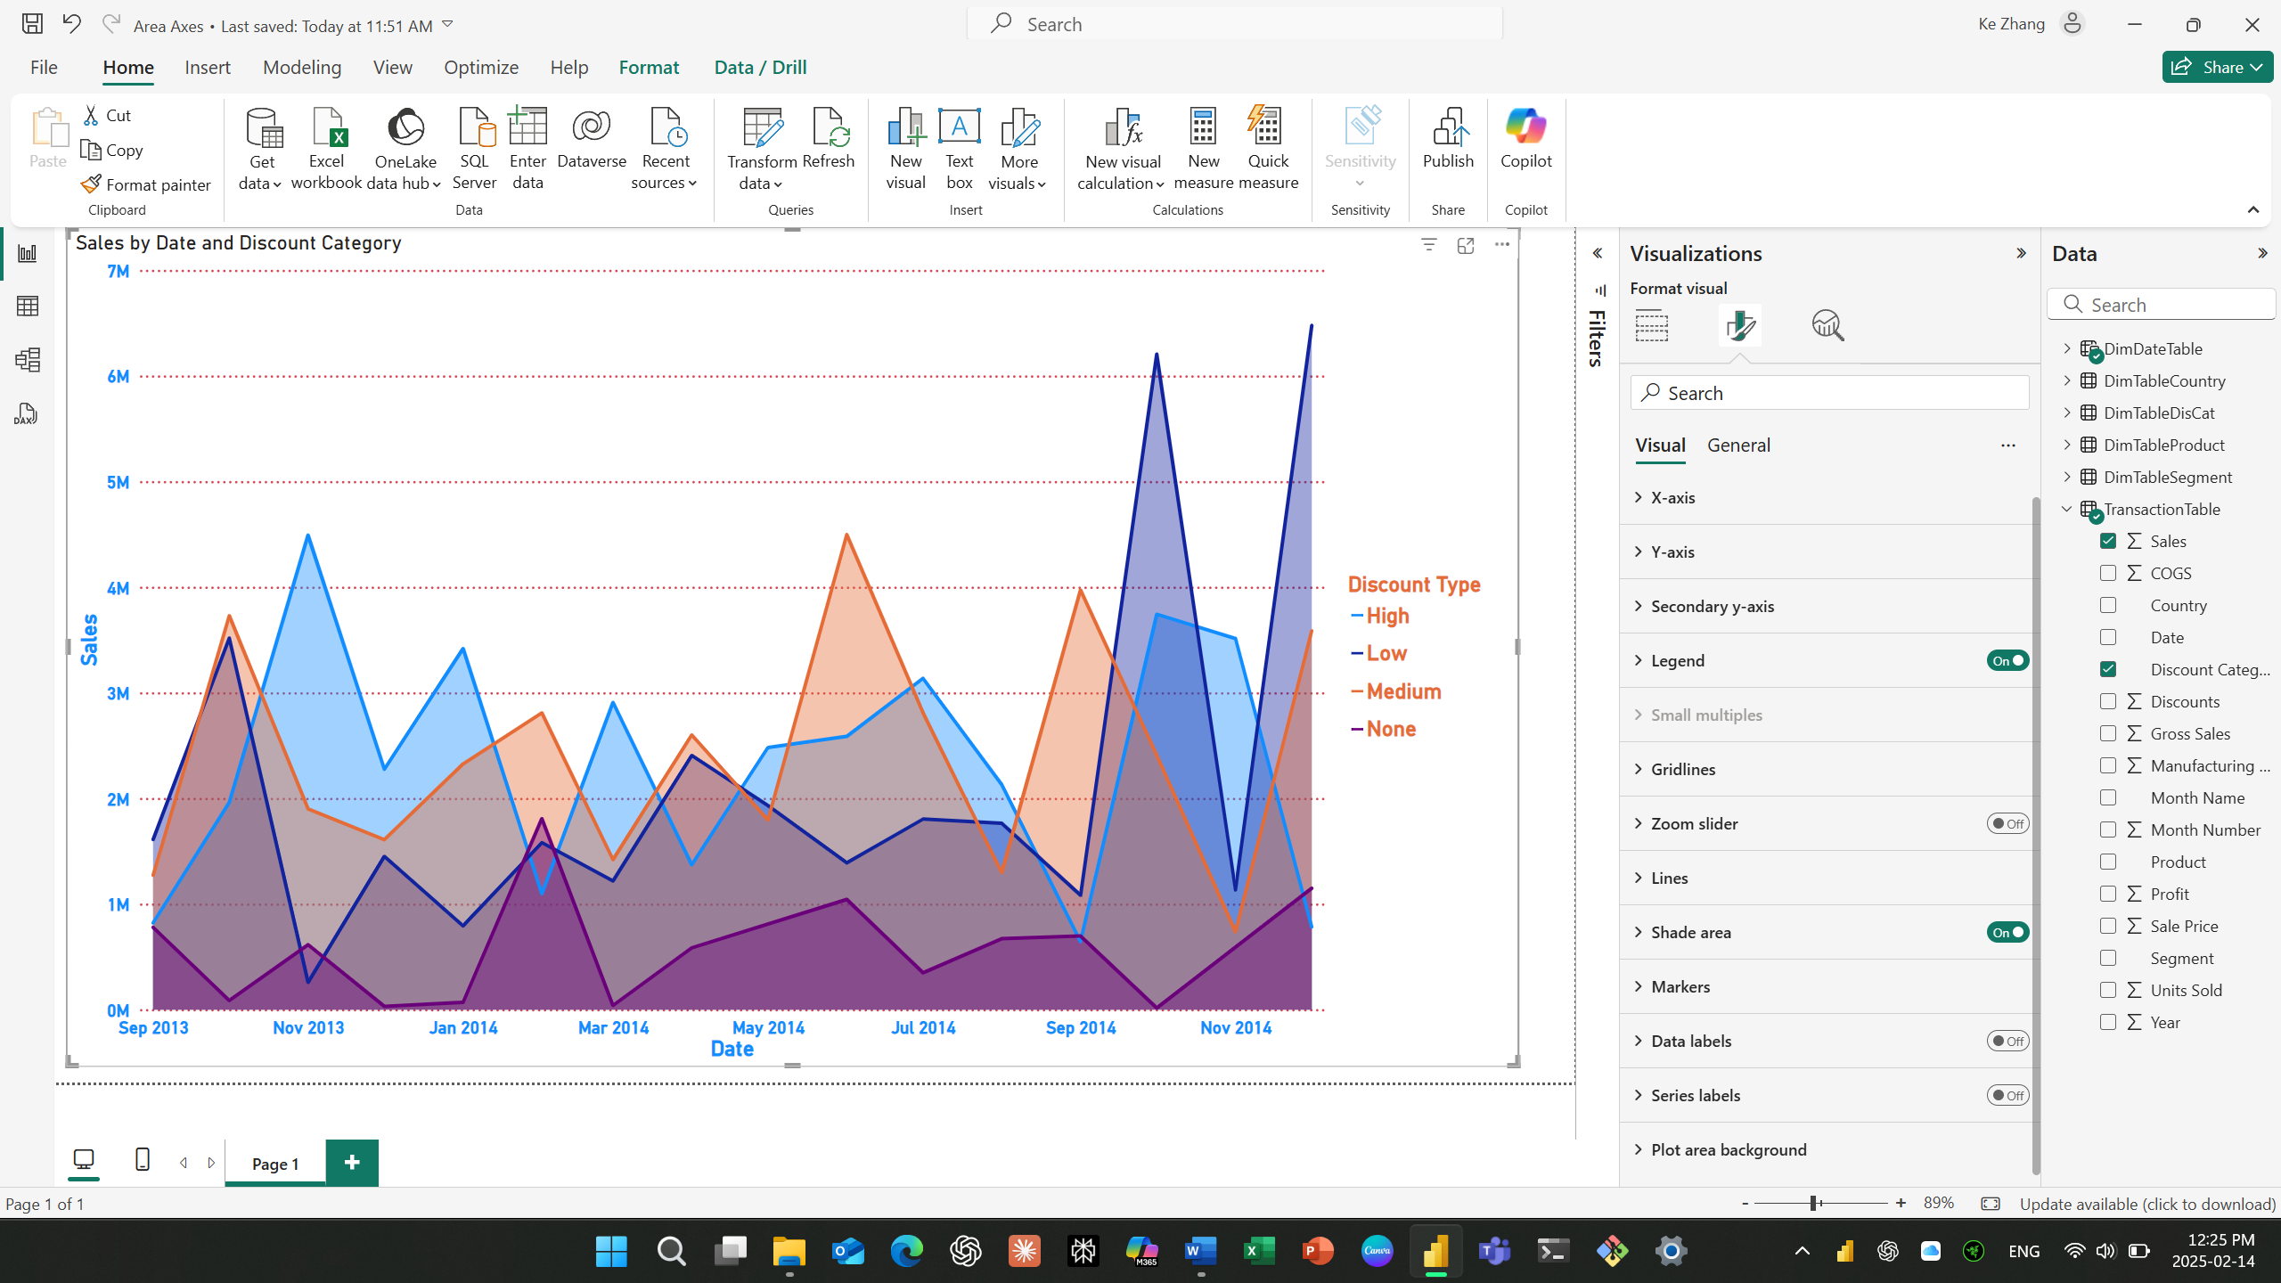

Question: Apply the following formatting options to the Area Chart. Take screen shots for each

adjustment.

1：Add Data Markers

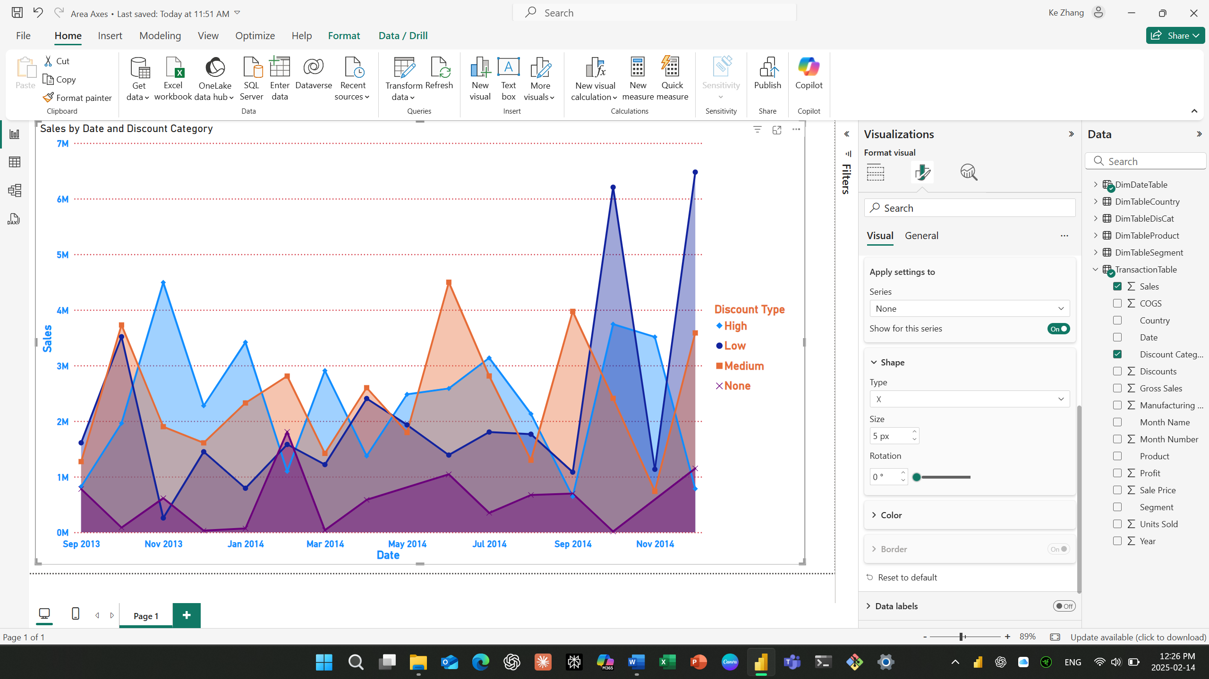

2. Add Data labels.

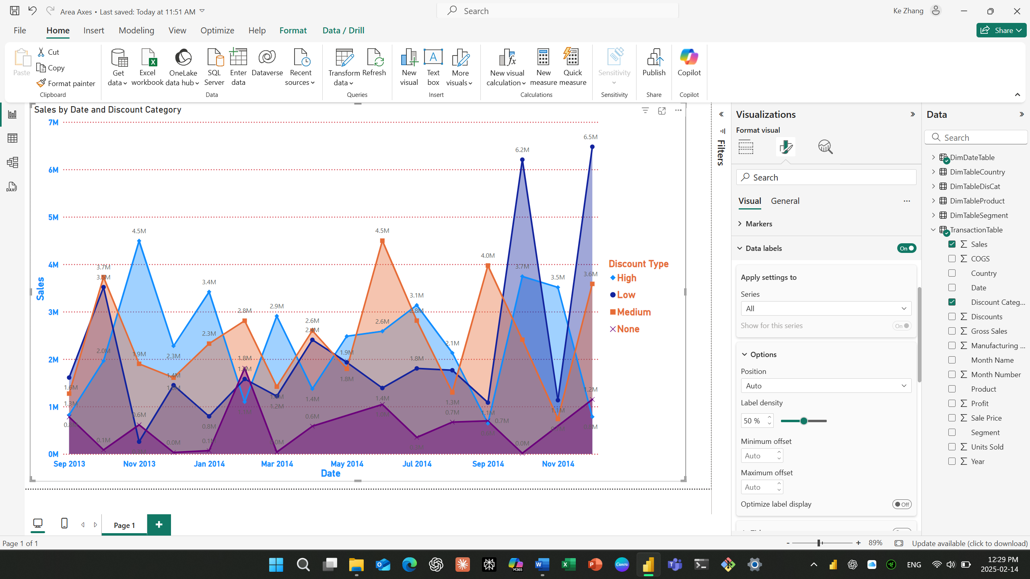

3. Change the Display units to (Thousands) for the Data Labels.

